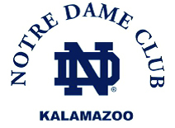

**http://undkalamazoo.org**

**70th Annual ND Scholarship Golf Outing   
 Gull Lake Country Club ● Monday, July 10th, 2023**

**10:00 a.m.:**  Registration   
**11:00 a.m.:** Cookout Buffet at the Greenside Grill  
**12 noon:** Shot Gun Start   
**Dinner, Speaker, Live Auction & Awards following golf**  
  
**● Golf, Lunch & Dinner: $200.00 per person or $800/Foursome**Includes beverages on the course, mulligans, putting string, golf prizes and hole-in one car chance.

**● Hole Sponsorship Levels** (includes custom tee sign)**:  
$1,500 4 tickets to ND/Ohio State (9/23)**

**$150 Tee Sign Sponsorship w/logo**

**● Other Sponsorship Levels  
$60 Dinner only   
$250 Meal Sponsorship - includes recognition/signage at lunch, dinner & on website**

**Registration and paid in full deadline is Friday, July 7, 2023  
To register/pay online go to:** <https://secure.qgiv.com/for/notredameclubofkalamazoo/event/notredameclubofkalamazoogolfouting2023/>



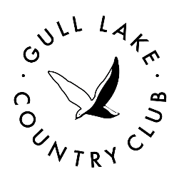Make checks payable to **The Notre Dame Club of Kalamazoo**Mail payment to: **P.O. Box 2513, Portage, MI 49081-2513  
  
Reservations and Questions, please contact Dan Adams:**dadams@joldersma-klein.com or 269.806.2451  
Credit cards accepted at outing